Benefit Summary
for full-time employees
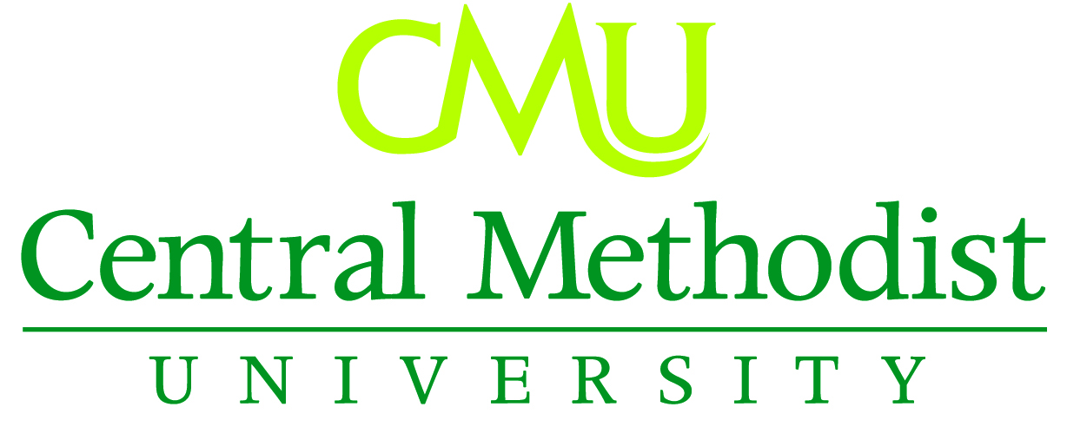

Medical Insurance*
Medical insurance is offered through Anthem Blue Cross and Blue Shield. Three plans are available for your choosing. The Select plan has no deductible, and 80% coinsurance, if you use in-network physicians and facilities, 60% outside network. The PPO offers more flexibility, and has a $2,500/person or $5,000/family deductible. The HSA has a $3,200/person or $5,600 /family deductible and CMU contributes $50.00 per month to this savings plan.
- Medical Premiums
Coverage | Select Monthly Premium | PPO Monthly Premium | Health Savings (HSA) Monthly Premium
Spouse | $807.70 | $813.15 | $731.29
1 Child  Children | $325.26  $649.43 | $327.45  $654.89 | $299.06  $598.13
Family/Child  Family/  Children | $1,132.95  $1,457.12 | $1,140.59  $1,468.04 | $1,030.35  $1,329.42
Dental Insurance*
CMU offers dental coverage through Delta Dental. The plan covers preventive services 100%, basic services at 80%, and major services at 50%. A deductible of $50 applies to basic and major services. There is a $1,000 calendar year maximum benefit.
Dental Premiums
Coverage | Monthly Premium
Spouse | $32.16
Child(ren) | $32.16
Family | $66.38
Basic Life and AD&D*
CMU provides Basic Life Insurance through Anthem to all full-time employees. The Life benefit is based on your salary. The Life benefit reduces starting at age 65 and every five years after.
Salary | Life Benefit
Less than $30,000 | $35,000
$30,000 and Above | $50,000
Long-Term Disability*
CMU provides income protection in the form of Long-Term Disability (LTD) coverage through Anthem. Following a 180-day waiting period, monthly disability benefits provide 60% of your salary.
Voluntary Life*
Employees have the option to elect supplemental life insurance for oneself or family members through Anthem.
Flexible Spending Accounts (FSA)*
The FSA allows you to set aside pre-tax dollars to pay for certain types of medical expenses. The maximum you can defer for unreimbursed medical, dental and vision expenses is $3,300. The maximum deferment for dependent care is $5,000. Participants must re-enroll every calendar year.
Vision Insurance (Voluntary)
VSP, a leading vision insurance provider, offers a program called VSPDirect which allows you to purchase an individual vision policy. Search for plans and providers at the following website: https://www.vspdirect.com. Note: As this is an individual policy between you and VSP, CMU does not administer this benefit. Vision discounts are also available through our health insurance plan with Anthem.
Time Off
Vacation: Non-exempt employees accrue 2 weeks per year; exempt employees accrue 3 weeks per year

Sick: All employees accrue 1.25 days per month

Holidays: Varies based on the calendar, but averages between 17– 19 holidays each year for full time 40 hour a week employees.
Tuition Assistance
Undergraduate tuition covered 100% for employee, spouse and dependent children. Graduate tuition covered 100% for employee and 50% for spouse. The benefits received by spouses for classes in the graduate program will be taxable to the employee.

*Insurance benefits begin the first of the month following 30 days of full-time employment. Insurance premiums for full-time employees are paid 100% by CMU if they employee participates in the wellness program.Employees may choose to pay premiums for family, spouse, or dependent coverage with pre-tax dollars.

Retirement
The retirement plan for Central Methodist University is through TIAA and is a 403b retirement plan. The one year waiting period will remain in force for CMU’s contribution for new full-time employees.

In the Fall of 2016, Central Methodist’s employer contribution formula changed to the following: Eligible employees will receive a 3% employer base contribution, plus a 100% (or dollar-for –dollar) employer match on the first 1% the employee contributes and a 50% (or 50 cents- per –dollar) employer match on the next 7% the employee contributes. (See table)

Any employee who was auto-enrolled at 3% in the Fall will have their contribution rates automatically increased (auto-escalation) by 1% per year beginning in the Fall of 2017 until they reach an employee contribution rate of 8%.

Employees will always have the right to opt out of auto-enrollment and auto-escalation, and may select their own contribution rate at any time. However, we strongly encourage all employees to achieve an 8% contribution rate as soon as possible in order to receive maximum University contributions.

 | Retirement Plan
Employee Contribution | CMU Base  Contribution | CMU  Match | Total  Savings Level
0% | 3% | 0% | 3%
1% | 3% | 1% | 5%
2% | 3% | 1.5% | 6.5%
3% | 3% | 2% | 8%
4% | 3% | 2.5% | 9.5%
5% | 3% | 3% | 11%
6% | 3% | 3.5% | 12.5%
7% | 3% | 4% | 14%
8% | 3% | 4.5% | 15.5%

*Immediately 100% vested

Updated 01/01/2025
Exercise Facilities
Cardio Room (Rec Center)
7 Days a Week:
24/7 with ID Card access

Philips-Robb Recreation Center
Monday - Friday: 8:00 a.m. - 11:00 p.m.
Saturday -Sunday: 1:00 p.m. – 11:00 p.m.
Pool
Monday- Friday: 8:00 am – 10:00 am
12:00 pm – 4:00 pm
Puckett Field House - Indoor Track
Davis Field – Outdoor track
(Available when teams or athletics are not using)

This summary is published for employees of Central Methodist University, and is only a highlight of our benefits. Official plan and insurance documents actually govern your rights and benefits under each plan. If any discrepancy exists between this bulletin and any of the official documents, the official documents will prevail.

